Task on mount s3 bucket on ec2 instance

1. Create one iam user with programatic access of cansole.
2. Copy pest secrate key and acess key of that user.
3. Attach policy of that user of IAM EC2 and S3 full access.
4. Then launch one EC2 instance.
5. In that cansole go through root user and install repositary with help of below command.
6. 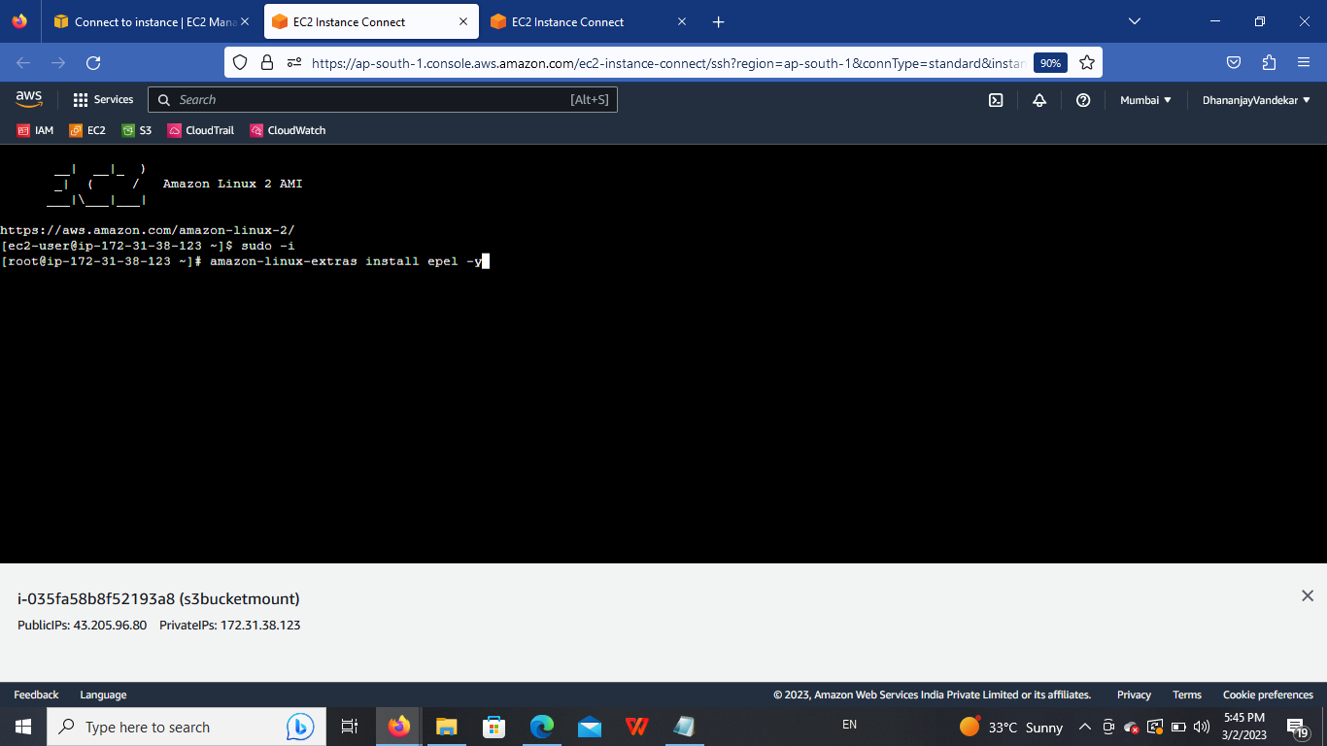

Then install s3fs package on instance with the help of below command.

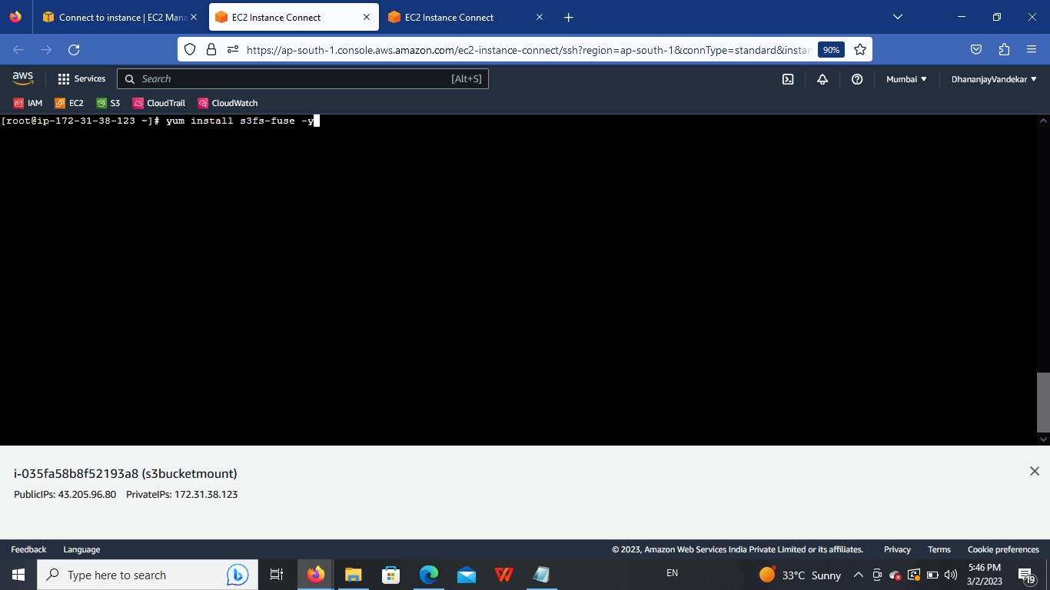

Then add secrate key and access key of user with S3permission ti get access with user access keys on ec2 instance.for that below command is use.

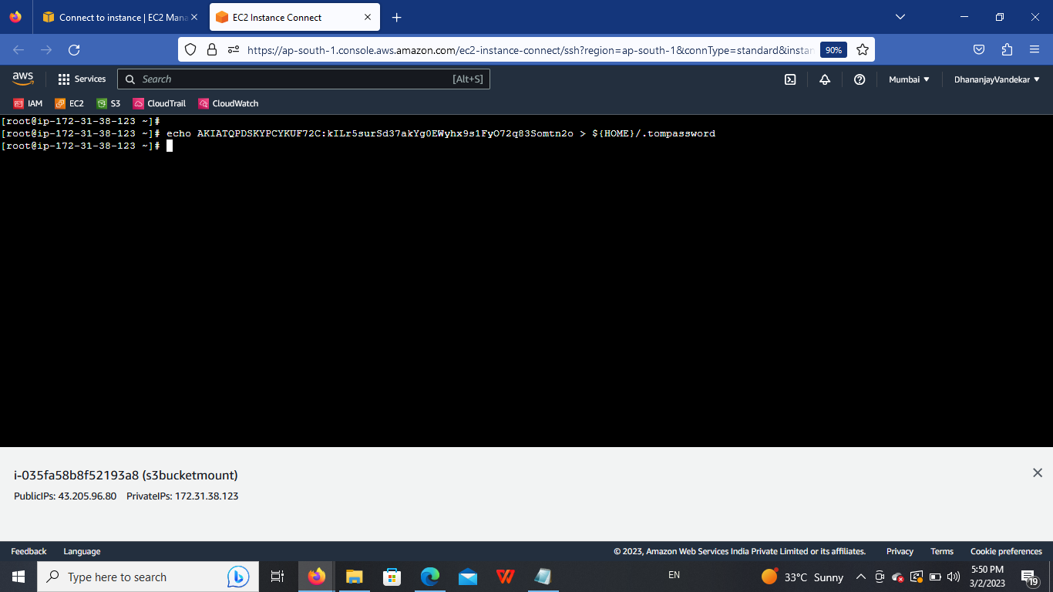

Then chek file is created or not with help of ls -la command.

Then change the permissio of file so evryone cannot access it give 600 permisssion to that file.

Then create one directory for mounting our bucket.

After that mount bucket which we want in that directory with the help of below command.

Then cd to that directory and create file same file will be appear in our s3 bucket.

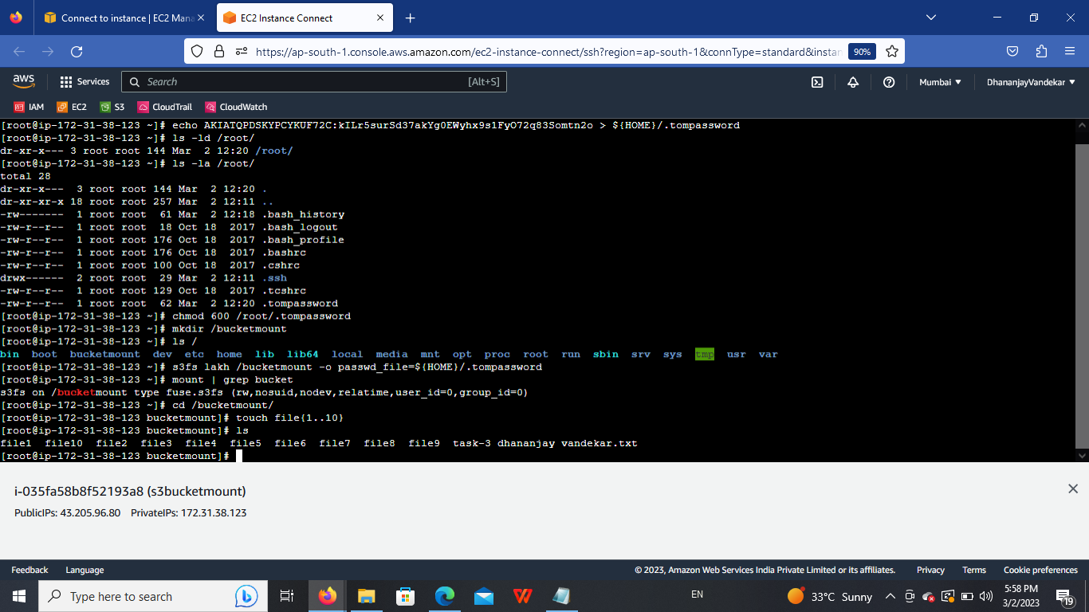

Then go to our S3 bucket and see file also created in that bucket.

